Lab Assignment 9

Done By: Rohit Karunakaran
Date: 18-11-2020

Experiment 10

Aim: Write a Java program that works as a simple calculator. Arrange Buttons for digits and the + - * / operations properly. Add a text field to display the result. Handle any possible exceptions like divide by zero. Use Java Swing.

Concepts Used: Java Swing and event hanling

Algorithm:

Class Calulator

- Create JFrame with title Calculator and setDefaultCloseOperation to EXIT_ON_CLOSE
- Set the layout manger for the JFrame to GridBagLayout
- Create the JLabel to display the result and to show the numbers entered
- Add the Jlabel to `display` the number entered and the result
- Add the Jbuttons with the symbols 1,2,3,4,5,6,7,8,9,0 for the numbers and +,-,*,/ for the operations
- //Event handling
- For every numberbutton:
- if the button is pressed, append the character to the Jlabel
- Done

- If +,-,*,/ button pressed
- case + : add = true,sub=false,mul=false,div=false
- break
- case - : add = false,sub=true,mul=false,div=false
- break
- case * : add = true,sub=false,mul=true,div=false
- break
- case / : add = false,sub=false,mul=false,div=true
- break
- endcase
- a = Float.valueOf(display.getText())
- endFor

- If ‘=’ button is pressed
- flag =false
- if(add or sub or mul or div of mod)
- b = Float.valueOf(display.getText())
- case add: res=a+b
- break
- case sub: res = a-b
- break
- case mul: res=a*b
- break
- case div: if b==0
- flag=true
- else
- res = a/b
- endif
- endcase
- if flag then
- display.setText(“Divide by 0 error”)
- else
- display.setText(res)
- endif
- endif

Result: The program is successfully compiled and the required output is obtained

Program code:

/****************************************
* Calculator implementing the funtions +,-,*,/
* Done By: Rohit Karunakaran
* *************************************/
import java.awt.*;
import java.awt.event.*;
import javax.swing.*;

public class Calculator
{
JFrame jfrm;
JLabel disp;
GridBagConstraints c ;
ActionListener numberButtonPressed;
ActionListener mathButtonPressed;
boolean add;
boolean sub;
boolean mul;
boolean div;
boolean done;

double calc;

public Calculator()
{
jfrm = new JFrame("Calculator");
jfrm.setLayout(new GridBagLayout());
c = new GridBagConstraints();
calc = 0;
add=false;
sub=false;
div=false;
mul=false;
done = true;

jfrm.setSize(270,330);
jfrm.setDefaultCloseOperation(JFrame.EXIT_ON_CLOSE);

disp = new JLabel(String.valueOf(calc));

numberButtonPressed = new ActionListener()
{
public void actionPerformed(ActionEvent ae)
{
JButton callerButton = (JButton)ae.getSource();
String val = callerButton.getText();
String displayText = disp.getText();

if(displayText.equals("ERROR"))
{
disp.setText(val);
}
else
{
if(done ==true){
disp.setText(String.valueOf(Double.parseDouble(val)));
}
else{
double newVal = Double.parseDouble(displayText)*10+Double.parseDouble(val);
disp.setText(String.valueOf(newVal));
}
}
done = false;
}
};

mathButtonPressed = new ActionListener()
{
public void actionPerformed(ActionEvent ae)
{
//done = true;
JButton b = (JButton) ae.getSource();
double result = 0.0;
String val = disp.getText();
if(!done)
{
if(val.equals("ERROR"))
{
disp.setText("0.0");
calc = 0.0;
}
else
{
if(add||sub||div||mul)
{
double operand= Double.parseDouble(val);
if(add)
{
result = calc+operand;
add = false;
}
else if(sub)
{
result = calc-operand;
sub = false;
}
else if(mul)
{
result = calc*operand;
mul = false;
}
else if(div)
{
if(operand!=0.0)
result = calc/operand;
else{
disp.setText("ERROR");
done = true;
return;
}
div = false;
}
calc = result;
disp.setText(String.valueOf(calc));

}
else
{
calc = Double.parseDouble(val);
char op = b.getText().charAt(0);
switch(op)
{
case '+':add=true;break;
case '*':mul=true;break;
case '/':div=true;break;
case '-':sub=true;break;
}
}

}
done = true;
}
}
};

c.anchor = GridBagConstraints.FIRST_LINE_START;
c.fill= GridBagConstraints.VERTICAL;
c.weightx=0.5;
c.gridx=0; c.gridy=0;
c.gridwidth = 3;
c.ipady = 20;

jfrm.add(disp,c);
addButtons();
jfrm.setVisible(true);
}

private void addButtons()
{
c.ipady = 10;
c.gridwidth = 1;
c.fill= GridBagConstraints.HORIZONTAL;
c.anchor = GridBagConstraints.LINE_START;
JButton numbers[] = new JButton[10];
for(int i = 0;i<10;i++)
{
numbers[i] = new JButton(String.valueOf(i));
numbers[i].addActionListener(numberButtonPressed);
if(i!=0)
c.gridx = (i+2)%3;
else
c.gridx = 1;
c.gridy = i%3==0?4-(i/3-1):4-(i/3);
jfrm.add(numbers[i],c);
}
JButton addButton= new JButton("+");
addButton.addActionListener(mathButtonPressed);

JButton subButton= new JButton("-");
subButton.addActionListener(mathButtonPressed);

JButton mulButton= new JButton("x");
mulButton.addActionListener(mathButtonPressed);

JButton divButton= new JButton("/");
divButton.addActionListener(mathButtonPressed);

c.gridx = 3;
c.gridy = 2;
jfrm.add(addButton,c);
c.gridy = 3;
jfrm.add(subButton,c);
c.gridy =4;
jfrm.add(mulButton,c);
c.gridy = 5;
jfrm.add(divButton,c);

JButton equalButton = new JButton("=");
equalButton.addActionListener(new ActionListener()
{
public void actionPerformed(ActionEvent ae)
{
double result = 0.0;
String val = disp.getText();
if(!done)
{
if(val.equals("ERROR"))
{
disp.setText("0.0");
calc = 0.0;
}
else
{
if(add||sub||div||mul)
{
double operand= Double.parseDouble(val);
if(add)
{
result = calc+operand;
add = false;
}
else if(sub)
{
result = calc-operand;
sub = false;
}
else if(mul)
{
result = calc*operand;
mul = false;
}
else if(div)
{
if(operand!=0.0)
result = calc/operand;
else{
disp.setText("ERROR");
done = true;
return;
}
div = false;
}
calc = result;
disp.setText(String.valueOf(calc));
}
else
{
calc = Double.parseDouble(val);
}

}
done = true;
}
}
});

c.gridy=5;
c.gridx =2;
jfrm.add(equalButton,c);

c.gridx = 0;
JButton clearAll = new JButton("AC");
clearAll.addActionListener(new ActionListener()
{
public void actionPerformed(ActionEvent ae)
{
add = mul = div = sub = false;
done = true;
disp.setText("0.0");
}
}
);
jfrm.add(clearAll,c);

}

public static void main(String[] args)
{
SwingUtilities.invokeLater(new Runnable()
{
public void run()
{
new Calculator();
}
});
}
}
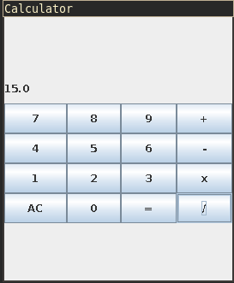
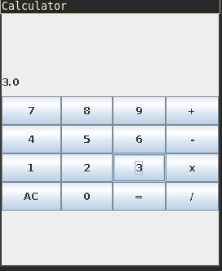
Sample output

12+3 =15
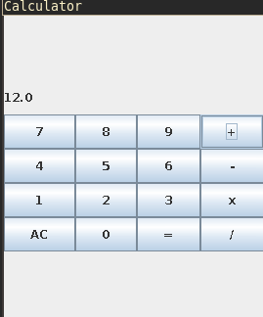

15 / 0 = ERROR

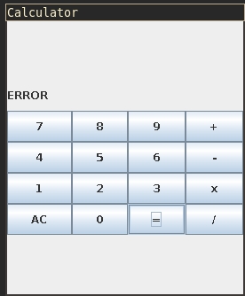
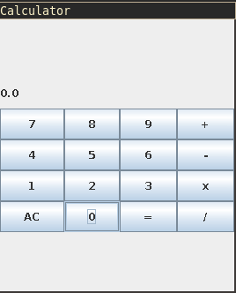

Experiment 11

Aim: Write a Java program that simulates a traffic light. The program lets the user select one of three lights: red, yellow, or green. When a radio button is selected, the light is turned on, and only one light can be on at a time. No light is on when the program starts.

Concepts Used: Awt, Swing, Event handling

Algorithm:

- Create 3 JradioButtons buttons[] with the values “Red” “Yellow” “Green” for the three buttons
- buttons[0].setBackground(Color..GRAY)
- buttons[2].setBackground(Color..GRAY)
- buttons[1].setBackground(Color..GRAY)

- add the buttons to the Jframe
- Create a ButtonGroup bg
- Add the buttons to bg
- //Event handling
- button[0] is pressed
- set button[1] and button[2] to Grey
- set button[0] tored
- button[1] is pressed
- set button[1] to yellow
- set button[0] and button[2] to Grey
- button[2] is pressed
- set button[2] to green
- set button[0] and button[1] to Grey

Result: The program was compiled successfully and the required output was obtained.

Program Code

import java.awt.*;
import javax.swing.*;
import java.awt.event.*;

class TrafficLights{
TrafficLights(){
JFrame jfrm = new JFrame();
jfrm.setLayout(new GridLayout(3,1));
jfrm.setDefaultCloseOperation(JFrame.EXIT_ON_CLOSE);
jfrm.setSize(200,500);
JRadioButton signalButtons[] = new JRadioButton[3];
ButtonGroup bg = new ButtonGroup();

signalButtons[0]=new JRadioButton("Red");
signalButtons[0].setBackground(Color.GRAY);;

signalButtons[1]=new JRadioButton("Yellow");
signalButtons[1].setBackground(Color.GRAY);;

signalButtons[2]=new JRadioButton("Green");
signalButtons[2].setBackground(Color.GRAY);;

bg.add(signalButtons[0]);
bg.add(signalButtons[1]);
bg.add(signalButtons[2]);

jfrm.add(signalButtons[0]);
jfrm.add(signalButtons[1]);
jfrm.add(signalButtons[2]);

signalButtons[0].addActionListener(new ActionListener(){
public void actionPerformed(ActionEvent e){
signalButtons[0].setBackground(Color.RED);
signalButtons[1].setBackground(Color.GRAY);;
signalButtons[2].setBackground(Color.GRAY);;
}
});

signalButtons[1].addActionListener(new ActionListener(){
public void actionPerformed(ActionEvent e){
signalButtons[0].setBackground(Color.GRAY);
signalButtons[1].setBackground(Color.YELLOW);;
signalButtons[2].setBackground(Color.GRAY);;
}
});

signalButtons[2].addActionListener(new ActionListener(){
public void actionPerformed(ActionEvent e){
signalButtons[0].setBackground(Color.GRAY);
signalButtons[1].setBackground(Color.GRAY);;
signalButtons[2].setBackground(Color.GREEN);;
}
});
jfrm.setVisible(true);

}
public static void main(String[] args){
new TrafficLights();
}

}

Sample output

